THE SAVIORS

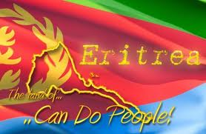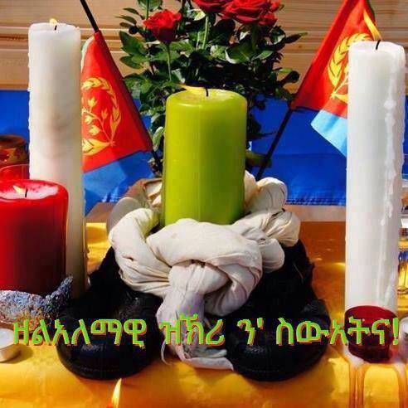

By: Dawit Ghebremedhin

They are the souls who entered a destiny.

They have such an identity.

The ones who overcame all odds.

They are the ones who have the unique imperial thoughts.

They fought for a whole country.

Having little near nothing.

In indescribable situations. Feeling like this was a perpetuation.

Eritrea a country underground brought up these special people.

A mindset that their life did not matter but Eritrea was an essential factor.

Enduring a magnitude of pain. But their determination was fast as a train.

A life lasting message held in their heart.

All their precious beloved things left in a cart.

They decided to fight at a young age.

In life they were turning the page.

They are remembered as the saviors who defeated darkness.

Our enemies were fooled by their cunningness.

We represented a country in shambles but instead built a structure in a gamble.

But it paid off for our dedicated warriors.

They were the potent carriers of a cherishing priceless thing called freedom.

It costs us a price that marks a permanent scar. It is remembered not far.

They are essential aspects of Eritrean history being big pieces of a powerful puzzle that represents our dear country.

One day is not enough to thank you.

They are the angels of our beloved land.

They lent us a mighty hand.

We can never live life without them.

They now deserve a seat on the distinct pew.

Their distinctness we will never have another.

They are our Martyrs.

Glory to our Martyrs.

Wetru Awet Nahafash!
