20 ሰነ ንዝኽሪ ጀጋኑ ስውኣትና ኣብ ከተማ ሳንድየጎ ካሊፎርንያ

Commemorate Eritrean Martyrs day in San Diego
Posted by Tesfagabir Redie on behalf of PFDJ Sandiego branch
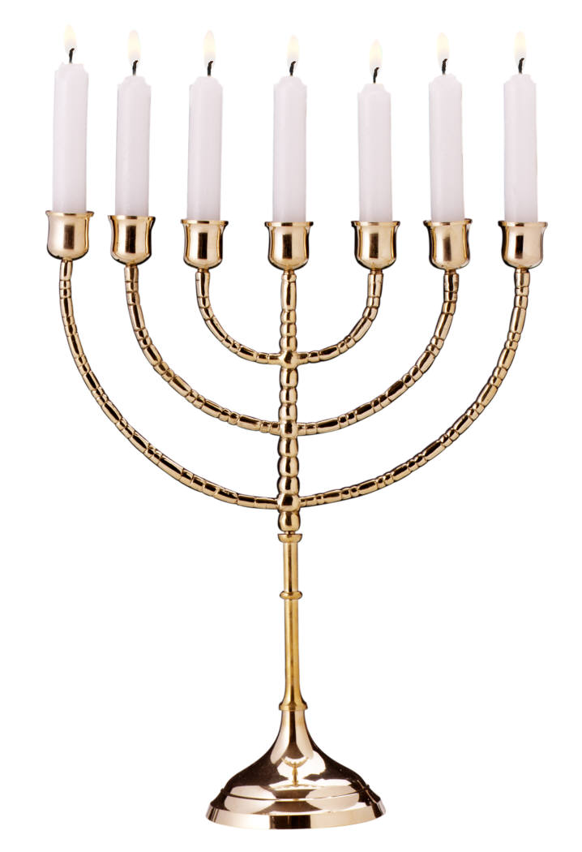

እንገብረሉ ቦታ፡ ኣብቲ ልሙድ ዝኾነ።
Lutheran Methodist Church
4650 Mansfield Avenue SanDiego, Ca. 92126
Time: 7:00 PM ግዜ፡ ካብ ሰዓት 7.00 ድ.ቀ.
Date:20th of June 2013 ዕለት፡ 20 ሰነ. 2013

