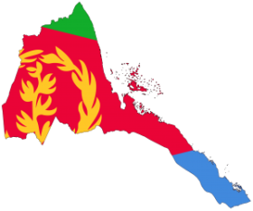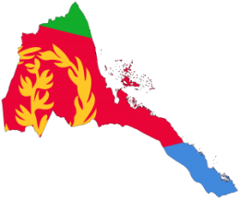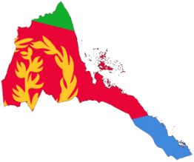
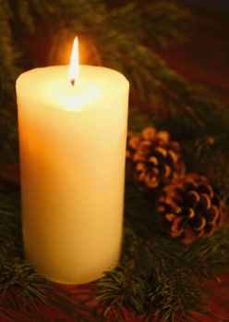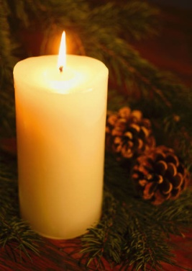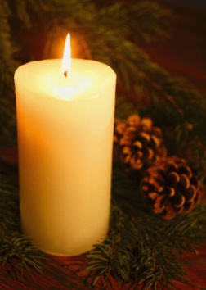
Eritrean martyrs day in charlotte, North Carolina will be commemorate On Sunday Jun 16, 2013 @ 6: 00 pm
Place = Freedom Park
1900 East Blvd.
Charlotte, NC 28203
Eternal glory to our martyrs
Awet n’ Hafash

