The E.P.L.F. is a hard nut to crack:
By Esayas Temesgen
June 6, 20013
The Erirean Tv, for the whole month of march through may, 2013; In memory of the twenty fifth anniversaries of the astonishing counter attack of the EPLF at Afabet, and in conjunction with the twenty second anniversary of Eritrean independence day. dedicated most of its program to disseminate documentary films from the archives , that depicts the valiant achievement of the EPLF during the liberation of the State of Eritrea.
Most of all the riveting live interviews of the eye witness account of the Eritrean experience, with the Heroes: the main actors of the revolution - who lived it all, was a very telling of The EPLF bravado.
Among the many brave ex-EPLF fighters, I watched who are humble; passionate; and considerate Eritreans, I chose to post these two heroes, only as a sample. Otherwise it is hard to chose one over the other, all most all EPLF fighters are of the same caliber in their field. One is as fasinating as the other .
Watching these two fascinating Erirean women, who at this moment are giving post independence civile service in different capacities, will give you the microscopic view of the EPLF fighters mind set; physical fortitude; and above all determination to sacrifice their life for the libertiy of their people without shillyshallying.
their high-spirited pictorial account of theirs and their comrades experience of the libration war, will keep you glued to the Tv Screen, you never let it go. At times you struggle with tears dripping dawn your eye- sensing their energy that reach you via the screen.
Reflecting on their past their presence keeps your hope alive, about the future of Eritrea. As they have sholderd the past, obvieuosly they are determend more than ever to overcome the present hardel and leap forward.
Under the steward ship of these brave Brothers and Sisters, Erirea is positiond to throw these yahoo’s, who are cooking chaos to distabilize Eritrea and to choke-hold its future to the dustbin.
Without dought these were their month, their time to speak, to tell us their stories; our part is to listen to the unbelievable- off the chart human indurance they encountered.
listening to these determined Brother and sisteres is always a learning exppreance, to how far Eritreans pushed endurance for the sake of libertiy: They go back to the front line - again and again to engage the envading Ethiopian army, despite the multiple wound they suffer; at times fourteen to fifteen: from bullet, and artillery -sharp nails.
Dr. Laynesh:
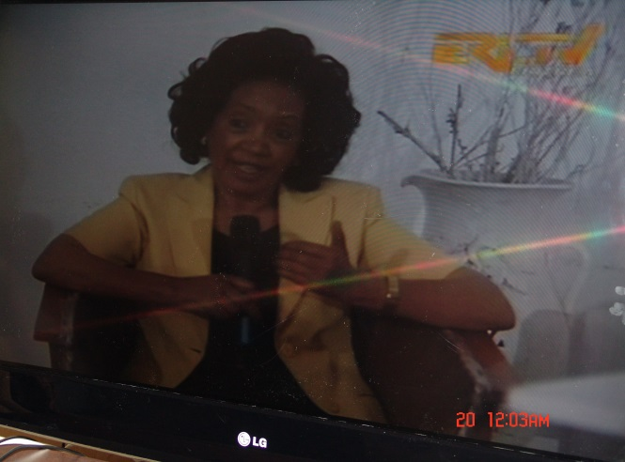
“Our history is a legacy that has to be writen and documented, for the future generation to keep the flow of information going.” [Dr. Laynesh].
Dr.Laynesh is a plastic surgeon that joind the EPLF at a very young age from abroad, to serve as a Medic-fihgter. This highly conciouse intelectual has done inconceivable plastic surgery on her comrades that have sufferd face damage, and lost thier jawbones; Including Many other hard to work- on wound in a very hostile inviorment to deal with casualty. Her Heroic duty didn’t stop there she has trained many nurses with surgical capacity; because of her unique personalitiy she has become the darling of Eritrea.
Bieng a women, she shades a dstingushable light to the Eritreaan struggle. otherwise I would haave equally like to mention those many other conciouse intelectuals and surgions, who have done things of the same magnitude. They all are a class act.
Ex Eplf fghter, Sister Asshha:
r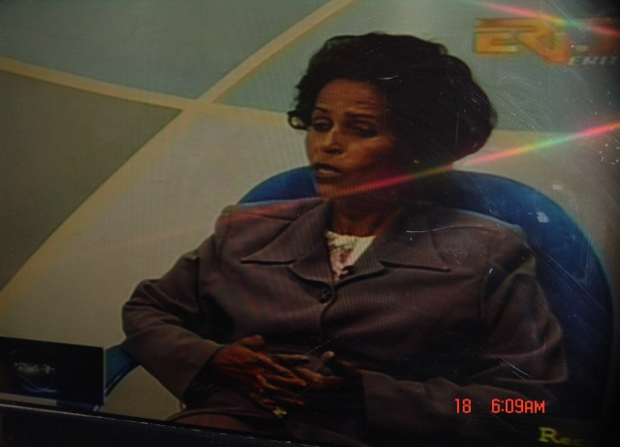
”from the get- go it was obvious to us, that Weyane has been sabotaging our struggle during the libration.” [Sister Asshha].
As most of her comrades, Asshha was a curageous guerilla fighter; a cadre; and urban underground cell organizer. She has been wounded multiple times; participated in many military engagements against the enemy at the front line. She is Currently serving as Eritrean Womens association leader in Keren.
Among the people calling the TV station during the live interview to give their recollection of her heroic deeds were her comrades, who knew her during the liberation war, while others call to express gratitude for her exceptional national service.

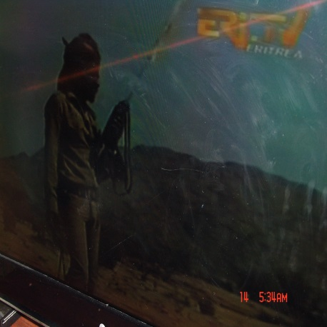EPLF Fighter on a lookout:

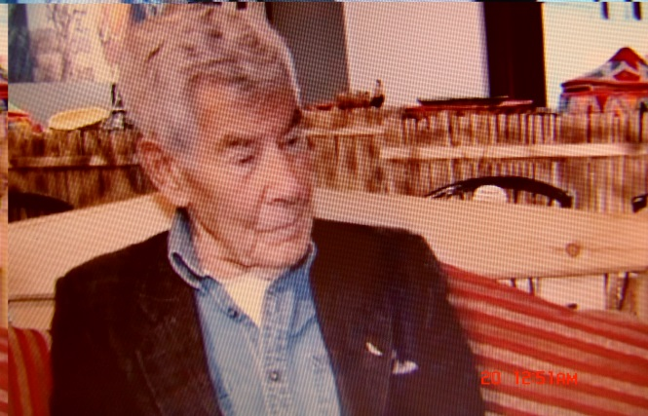Toronto Sun, founding Editor Peter Worthington:
“Until reminded of Eritrean celebrations, I’d more or less forgotten that I was there for the battle of Afabet [Nadew]-walking among the dead bodies; witnessing the pillaged Ethiopian Army headquarters and were Canadian food aid for refuges had been diverted to Army kitchens for Ethiopian soldiers.”
“Eritreans are right to be worry of foreign aid; it is like a mug pie it will take over your resources.” Toronto Sun, [Peter Worthington].
Peter Worthington a renowned Canadian journalist, while filming a TV documentary on EPLF, happened to witness the bloody war in real time as it was happening. He was a seasoned journalist with wisdom, who gave unbiased analyses about Eritrea.
Peter Worthington a son of decorated general and a war veteran himself, Was a legend and progressive loyal citizen, with high regard to humanity.
As a conscious journalist, peter dedicated his profession to voice for the overlooked; he tried to influence the west particularly his country Canada and the US; to reconsider their policy of inconsistency towards Africa and else.
Peter Worthington buried on May 22, 2013 at age eighty six: may rest in peace; he will be missed. As a veteran he was given a full military funeral procession, his casket draped with Canadian flag followed by a horse and a 21- gun salute final farewell.
My hat goes off to those Eritrean Canadians who went to his funeral with flower to say god bye to a dear friend of Eritrea.
In March 1988 The EPLF reversed the final and strategic assault on afabet ever by Expansionist Ethiopia, to dislodge it from its base known as “Nakfa.” Conversely the EPLF surprised the world by advancing forward smashing the largest military machine in Africa that was thrown at it, with the help of the soviet military hardware and expertise.
Since that humiliating defeat the enemy couldn’t hold its ground. As a result the Battle for “Nakfa” gave Eritreans the upper hand to end thirty years of vicious war, and enter Asmara the capital in 1991 to clinch a lasting victory over the expansionist Ethiopia.
To complete the work of demolishing the threat of expansionist Ethiopia, The EPLF has to chase it all the way thousands of kilometers, to dislodge it from all of its posts in Ethiopia, and finally unseating it from Addis Ababa the capital city ending the “Nakfa” Threat at its root.
The advent of the EPLF into the theater is a historical phenomenon that the objective reality required to strengthen Eritreans conviction to complete the journey of independence.
The EPLF didn’t win the war because it occupies a big land mass and a massive population, nor it is a damp of arsenal of the world powers. Certainly it wasn’t the darling of these powers for subsidies and loan.
The EPLF won the war only because of its skills to launch a working manifesto to rally the population and effective military strategy; that enabled it to obtain obedience from all sector of the population, regardless of age, religion and economic stratum.
This gave The EPLF the immunity to defy the pressure and blackmail of the outside forces. Hence: designed a war plan not to kill, and destroy; but to win and capture. In doing so, it became capable of arming itself with Tank and Artilleries’ from enemy inventory for the duration of the battle.
Consequently EPLF’s victory at Afabet changed the regional power game of the region- that is yet to evolve at its pace.
Eritrea because of its victory that made it the steward for the largest portion of the Red Sea: the world’s most strategic sea route in a most volatile region has shown its ability to liberate it and safeguard it from any kind of trespassers. Now Eritrea at helm of the red sea, definitely no bandits can park its ship and claim to be a king.
None the less, expansionist Ethiopia to no avail got back to its routine, and took another shot to retake Eritrea. No sign as yet of reversal of the trend: Expansionist Ethiopia is Hell-bent to retake Eritrea; as it did in the early nineteen fifties [by dissolving the parliament of then autonomies Eritrea]. Currently it is seating on Eritrean land [Badme] defying the international norm, not to abide by the outcome of the international court of arbitration, known as [The Ethio-Eritrea Border commission]; to use it as a staging ground for chaos and propaganda to destabilize Eritrea.
Expansionist Ethiopia has shown its strategy of “predatory.” That its survival depends on the distraction of its neighbors. Such as: Eritrea; Somalia; the Sudan; and recently Egypt…
It is high time that Eritrea erect monuments in the public parks and government buildings; in honor of those irreplaceable Heroes. So that their stories can be told for generation to come and their spirit of defiance could be felt among Eritreans in every day of their life.
They are generational Heroes, Who wrote the liberty of Eritrea with their blood and flesh. They stunned the world by overcoming a difficult war. Glory to them Eritrea is now steady; no matter what - no expansionist dreamer will dare to violate sovereign Eritrea; again.
Awet n’hafash!

