Learning the Lessons to be better than Ourselves
Dr. Tesfa G. Gebremedhin, West Virginia University
Everyone of us is defined by the kind of communities and religious institutions we belong to. We all have obligations to exercise our gift of life to build our communities and religious institutions, and see what life we can make for our own children. However, it is not pleasant to observe animosity and hostility in our Eritrean communities and religious institutions, which reflect lack of respect and tolerance to each other. We need to learn to be responsible for our attitudes to control our actions. Surely, we can learn a great deal from the following lessons.
Long ago in a faraway village in North America, there was a place known as the House of 1,000 Mirrors. A happy and nice little dog learned of this place and decided to visit. When he arrived, he bounced happily up the stairs to the doorway of the house. He looked through the doorway, with his ears lifted high and his tail wagging as fast as it could. To his great surprise, he found himself staring at 1,000 other happy little dogs with their tails wagging just as fast as his tail. He smiled a great smile, and was answered with 1,000 great smiles just as warm and friendly as his smile. As he left the house, he thought to himself, "this is a wonderful place. I will come back and visit it often." Likewise, another little dog, who was not happy and nice like the first one, decided to visit the House. He slowly climbed the stairs, his head hung low as he looked through the doorway. When he saw the 1,000 unfriendly looking dogs staring back at him, he growled at them, and was horrified to see 1,000 little dogs growling back at him. As he quickly backed away from the door to go out of the house, he thought to himself, "This is a horrible place, and I will never go back there again."

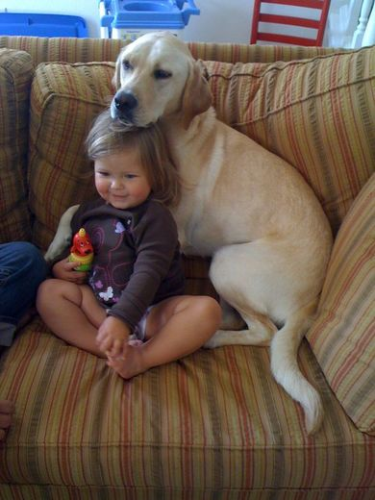
All the faces in the world are mirrors through which we see our reflections. The reflections we do see every day in the faces of the people we meet are the same reflections we make in our faces. The moral lesson of the story is that our positive or negative attitudes or personalities have a way of affecting our actions and the kind of reactions we get from people we meet. We control and react in response to what we want and we are responsible for what we get in response to our actions. If we are kind to others, we receive kind responses from them and vice versa. It usually pays off to be kind. The picture of a young boy and his caring dog shown above demonstrates all we need to know about kindness. I think the animals understand how to bring sunshine to the lives of others better than humans. What we can learn from such animals is that the greatest thing we can do is to treat everyone with kindness, even those who don’t deserve it. Life is short but there is always time for kindness and love. According to the Holly Quaran, “Those who act kindly in this world will have kindness” and also, “The best of men is the one who does well to others.” Obviously, if we are nice and kind to others, those who were helped by us will always remember and love us. As indicated in the Holly Bible, “no act of kindness, no matter how small, is ever wasted.” It is also true that if we go out to find a friend, we will never find one anywhere. But if we go out to be a friend, we will definitely find a friend everywhere.
Along the same line of thinking we can learn an important lesson about the desire of giving attention to somebody else. I was in Bahrain teaching at the University of Bahrain in 2009. One day at the end of a working day when my colleague and I were going out from our respective offices, one of the cleaning women was waiting for us to .leave before she starts to clean the offices. After saying hello to her, my colleague asked me at the stairway, if I knew the first name of the woman who cleans the offices. Surely, I have been seeing the cleaning woman every day when I leave my office and do smile and say hello to her. But how would I know her name? I asked him back, if it was important to know her name. "Absolutely," my colleague responded. He said, "Do not try to be yourself, try to be someone a little better and nicer. In your life and line of work, you will meet many kind of people and all are important and significant. They deserve your attention and care, even if all you do is smile and say hello." I heard him with great interest and since then I have never forgotten that lesson I have learned from him. As Jesse Jackson said, Never look down on anybody unless you are helping him or her up.’ It is nice to be important, but it is more important to be nice. In other words, anybody at any economic or social status, is important and significant in his or her own right in any community.
We can also learn another important lesson about the impact of spoken words in our interpersonal communication. It has been revealed in research that the way a person is addressed determines to a large extent the kind of response he or she would make. For example, when an individual is spoken to in a soft tone of voice, he would answer in a similar manner. But when he is shouted at, his reply would come back in the same sharp tone of voice. Other research has also indicated that if we answer a yeller gently in a soft tone of voice, he will have to lean forward to hear what we are saying and tend to lower his own tone of voice, This proves the truth of what the Bible taught so long ago: "A gentle answer turns away wrath, but a harsh word stirs up anger." A gentle word, a kind look and a good smile can work wonders and create miracles. The truth of the matter is that what we say and how we say it not only makes a difference in the reaction we will receive from each other, but it also determines whether conflict or peace will occur among ourselves. Many of our petty arguments entertained in our communities could be avoided and many of our tense and undesirable situations created in our religious institutions could be eliminated, if we understand and practice the truth of what the Holly books teach us.
As we are all aware, people need people in life because everybody in this world is connected to the rest of the world. Every Eritrean is a piece of each other and a part of the community. We need to be connected to each other with kindness and love to help each other because we are made up of the same substance of kinship. Obviously, there is no feeling more comforting and consoling than knowing that we are safe and connected to our own people in the Eritrean communities and religious institutions and go hand in hand with love and respect. When we show respect and kindness to each other, enmity and animosity will disappear, and love and friendship will flourish among ourselves. Thus, if we respect ourselves, others will respect us.

