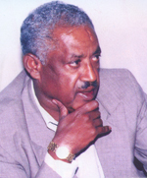
qÄ¥Y KÍL ¼23 GNïT 1999¼
http://www.dimtsiwoyane.com/ewanawizaeba/Ewanawi23091999.asx

µL¨Y KÍL ¼24 GNïT 1999¼
http://www.dimtsiwoyane.com/ewanawizaeba/Ewanawi24091999.asx

úLúY KÍL ¼25 GNïT 1999¼
http://www.dimtsiwoyane.com/ewanawizaeba/Ewanawi25091999.asx

‰B›YN ÂY mwÄX¬N KÍL ¼26 GNïT 1999¼
http://www.dimtsiwoyane.com/ewanawizaeba/Ewanawi26091999.asx

EDITORIAL: Part One: On the Interview Given by Sebhat Nega
By Tecola W. Hagos

http://www.tecolahagos.com/sebhat_nega.htm

