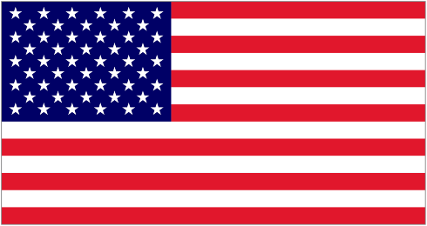
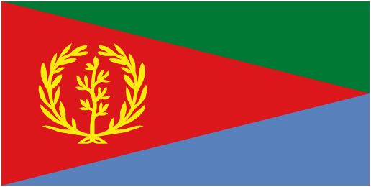
Eritrean Cultural and Development Center
357-359 Washington Street
Somerville, MA 02143

July 30, 2026

As part of it’s on –going educational programs, the ECDC (Eritrean Cultural and Development Center ) is sponsoring a seminar on ADDICTION. This is a free service to our community of greater Boston.
The Seminar will focus on the assessment, symptoms and treatment of alcohol and gambling. Some information regarding youth will also be discussed.
Date- Saturday October 2, 2010
Place – Eritrean Cultural and Development Center
Time- 5:00 PM Sharp
Presentations by- Dr. Tesfay Aradom
Wetru Awet N-hafash!
ECDC-BOSTON

