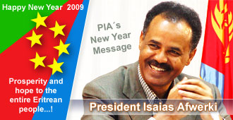

Ladies and Gentlemen:

Tune in to ERI-TV and Dimitsi Hafash on Sunday January 5th, 2009 to see an interview with his Excellency President Issias Afwerki on a range of issues.

When: Sunday, January 5th, 2008.

What: ERI-TV interview on a range of issues local (Eritrean) and International.

Where: Asmara, Eritrea

Time: 8pm Local Eritrea time/ 1pm East Coast time/12 (Noon) Central time/10pm Pacific time.

The Interview will be aired Live on ERI-TV and also will be carried live on Dimitsi Hafash. It can be also view via Hager Sat (Internet Television) as well as by clicking on

http://www.Alenalki.com

Tune in and listen to all the current issues affecting the Eritrean nation and the geopolitics of our region as well as what lies ahead for the year 2009 for Eritrea.

Awet N’Hafash

Zelalemawi Zikri Swtana.

Mike Seium

