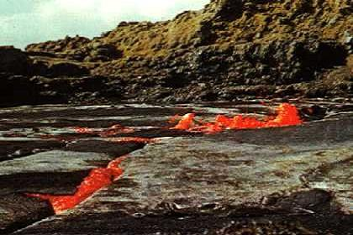
Erta Ale lava lake (Danakil Depression).

The Great Rift Valley was formed by a ripping motion when large land masses pulled apart. Around 40 million years B.C. the eastern coast of Africa experienced violent change and pulled away from the rest of the continent. It left behind a very long, steep-sided valley filled with volcanos. The valley filled with a huge inland sea which drained and refilled several times over thousands of years.
Stretching from the Red Sea coast of Eritrea through the mountains of Ethiopia, Uganda, Kenya and Tanzania, the Great Rift Valley finally ends in southeast Africa in Mozambique. It is named the Great Rift because it is the longest rift valley in the world.

