Fanfaronade lame hands stretching to the EU

It is déjà vu all over again. Back in 2004 when Eritrea was facing acute drought, some groups and individuals, the extent of whose complicity with the enemies of Eritrean peoples’ aspirations then scarcely known, lobbied the EU and other international organizations to stop giving emergency relief assistance to Eritrea. It doesn’t matter whether the entities that have been trying to undermine the GoE used such groups’ and individuals’ petitions to justify their conspiratorial measures or that the “concerned citizens” and some disgruntled individuals initiated the petitions themselves. Whichever side one wants to consider, it is not only immoral but also an abhorrently criminal act.

Apart from the fact that most of these so called “concerned citizens” do not even conform to the generic definition of citizenship, any individual who claims to be genuinely concerned about human rights would not be part of any endeavor that uses food as a political tool, especially in times of drought or impending famine. Indeed, these “concerned citizens” showed their true colors as their associates did during the Woyane (Ethiopian) third offensive when they took part in the desecration of the tombs of our Martyrs.

Actually, such crucial moments has brought to light the real motivations of those who, from the pulpits of state governments, international and regional organizations, have been making several demands and criticisms against the GoE after Eritrea took the necessary measures to safeguard its security and sovereignty. Until the occurrence of such revealing moments, many Eritreans in the Diaspora were confused by the myriad of voices that under the lofty ideals of human rights and what not were appearing as concerned citizens and advocates of justice and democracy.

Well, if those evil acts and intentions by those individuals and groups opened the eyes of many Eritreans in the Diaspora who were otherwise confused, one cannot also disregard the possible resonance such acts may have had on some conscientious officials of international organizations like the EU; nevertheless, in broader terms, what determines the future policy of the EU towards Eritrea is mostly based on the role it (Eritrea) plays in the critical and strategic Horn region.

Back in 2007, after the mercenary Woyane regime invaded Somalia to do the bidding of the Bush administration--- specifically, the neo-cons – Mr. Louis Michel, European Union Development Commissioner, paid visit to Eritrea; and to the surprise of our detractors and adversaries who had been striving for a total diplomatic isolation of Eritrea, he declared that Eritrea is a key partner of the EU in its efforts to bring peace and stability in the Horn region.
http://www.alertnet.org/thenews/newsdesk/L04519421.htm

Nevertheless, EU’s effectiveness has been relatively limited. Over the last eight years of neo-conic dominance of Washington, the EU which has been left with less room to exercise a meaningful influence could not manage to persuade the Woyanes to implement the verdict of the EEBC (Eritrea Ethiopia Boarder Commission).

So, what has changed since 2007? The no-war-no peace policy adopted by the Bush administration didn’t bear much fruit as to affect economic and state collapse in Eritrea; on the other hand, despite the total support given to their puppet Woyane regime, it didn’t emerge as a strong anchor state to effectively play its assigned role of policing the Horn region. Moreover, with the humbling developments in the global economic and political landscape, Eritrea is standing tall on its high moral grounds that a point has reached when it is hard for any group or organization to force its way or convincingly argue against Eritrean rightful interests.

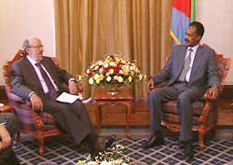
In the larger scheme of things, with the involvement of unlikely personalities and unpredictable events playing crucial role, Eritrean international relations evolves along complex trajectories which usually lead to unexpected positive outcomes. That leaves many political pundits, especially those who stand against the interests of Eritrea, puzzled and confused; in fact, their calculations are mostly based on erroneous assumptions or wishful thinking that could be relevant to many other cases, at best.

When Mr. Louis Michel stated that "EVERYBODY KNOWS ERITREA IS A KEY PARTNER AND A KEY ACTOR IN THE HORN" it was during a very challenging period when all sorts of accusations and blackmailing were directed against Eritrea. The hostile Bush Administration was then pandering to cover-up their (including the Woyanes) aggression in Somalia. What induced the EU through Mr. Louis Michel to take such an unexpected positive stand goes beyond normal diplomatic posturing, especially during such times of maximum adversities and challenges.

Well, as had been predicted by Eritrea, the Somalia adventure followed its destructive trajectory to a shameful termination. The mercenary Woyane army, which had hoped to renew its military adventures to the north, once it had accomplished the Somalia mission, found itself in a quagmire. Consequently, the stack of missions that had been planed to unfold in the Horn region got stuck with the first go. In view of such developments, and given its fair stand during those unfavorable times, what could possibly be the reason for the EU to make a policy change now, when unlike those challenging times, our enemies and detractors are losing their overwhelming leverage on global politics?

Going close to home, many of those who associate with our enemies are still confused or are in a state of denial about the current state of affairs of Eritrea; some have not yet grappled with the notion and reality of an independent Eritrea and some have failed to fulfill a mission that they have been entrusted to set in motion the transformation of Eritrea into an entity that can only be found in their delusional dreams alla Abbay-Tegray (Greater Tegray).

Such frustrations can be clearly seen in a recent editorial posted in one website which operates at arms-length with the prime enemies of Eritrea. Particularly, it features contributors and participants who display the Woyane FeraA-FeraA (fanfaronade) transposed into “Eritrean” political commentaries or soap operas, to say the least. This fanfaronade disposition is diametrically opposite to the ways and means of those they dare to call “little people”. FeraA-FeraA in the Eritrean political context is actually how real little people act out when they lose their socio-psychological compass— which is a permanent and distinct feature of the Woyane psyche. In a broader Eritrean context, it is a delusional mindset or disposition (Woyanes’ and of those who resonate with it) that tries to psychologically overwhelm others in its efforts to neutralize or substitute Eritreaness as perceived and defined by Eritreans.

One could question the relevance of discussing about the complexes and mental frames to that of the petty and perfidious petitions being presented to the EU. Simply put, such exposition makes much easier to alerting those who are not aware of the mentality of such characters or to reminding those who have some knowledge, historical or anecdotal, about the real objectives of most of the so called concerned citizens. Many a times, regardless of their stand towards Eritrea and its government, outside powers heavily rely on such duplicitous and dubious characters; in spite of their superficially appealing dispositions, as was demonstrated in the last ten years, the so called concerned citizens and their ilk have proven once again to be essentially inconsequential. To describe most of such characters as Eritrean Chalabis wouldn’t be accurate either; as far as we know, Ahmed Chalabi doesn’t question or doubt his Iraqi identity.

These fanfarons do not hesitate to belittle norms and practices that are unique to the Eritrean experience. In a tradition based on our modern era revolutionary experiences and the democratic tenets of our society, the “little people” do attend at different levels “peoples’ meetings” organized by our leaders.

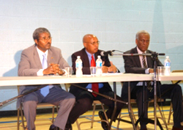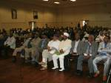

Dr. Woldai Fetur, Eritrean Minister of Development, conducting seminar at the Toronto Eritrea Festival.

However, according to the elitist mindset of the fanfarons within the “concerned citizenry”, such democratic exercise is understood basically as meetings where “annoying little questions” are raised and discussed; yet, they did not understand that it has been such a unique Eritrean/Shaebia experience that has puzzled many “powerful people” who have been devising ways of diluting such fundamental elements of what is essentially a basis of participatory democracy, in the Eritrean revolutionary tradition. Never mind, time has changed and Eritrea can share its experiences of the popular “peoples meetings” of the “little people” from which responsive and responsible leaders feel the heart beat of their people and extract wisdom to successfully challenge the “powerful people” and their cadres of fanfarons.

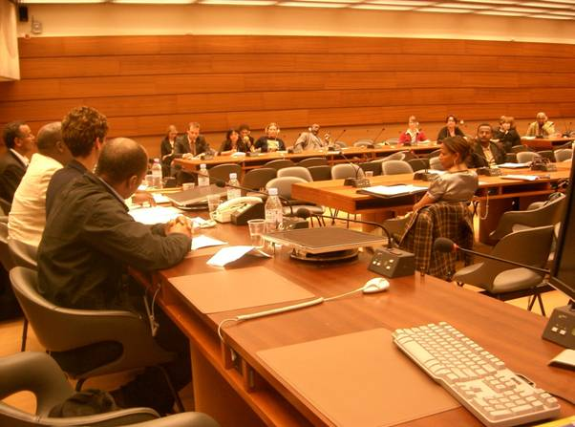
Those entities who have tried to damage Eritrea and its achievements have been using these fanfarons, albeit without success. Now it is not hard to see over the horizon, that many nations and organizations are about to establish partnership with Eritrea based on mutual interest and respect. They are welcome to benefit from the reciprocity of the “little people” who have made possible a miracle in
One of the “Eritrean” fanfarons conference.
the shaping of a “tiny Red Sea” state called Eritrea.

Much can be said about the petition that the fanfarons have written to the EU. In their humble but firm ways, some patriotic Eritreans have also written interesting rebuttals; not only does it show the stark difference in their respective mind set, but it also shows the resolute and defiant attitude of the “little people”. For those interested, read one prepared by non other than a respected member of the Diaspora who identifies himself with the “little people” who do respect and value partnership but reject and challenge any call for dependency-- in one form or the other.
http://meadna.com/business%20page/Commentary%20pages/The%20European%20Commission.htm

As Eritrea moves forward, despite the increasing retreat of the agencies of hostilities and conspiracies, it is incumbent upon the “little people” to clearly inform those who have interest in our region not to waste their time and resources or design policies based on the hollow promises and delusional analysis of the so called concerned Eritreans, or better inconsequential fanfarons.

Awet nHafash!
Haileab Luul Tesfai
Toronto.

